**Lab 19. SR Latch**

1. Part lists:
2. 4001 IC
3. Two Red LED lights: L1 and L2
4. Two 4.7KΩ Resistors (yellow, violet, red): R1 and R2
5. Two 33KΩ Resistors (orange, orange, orange): R3 and R4
6. Two 1KΩ Resistors (brown, black, red): R5 and R6
7. Make the connections based on Fig.1 sketch diagram.

**Fig. 1 Sketch diagram**

The pin diagram of 4001 IC is shown below:

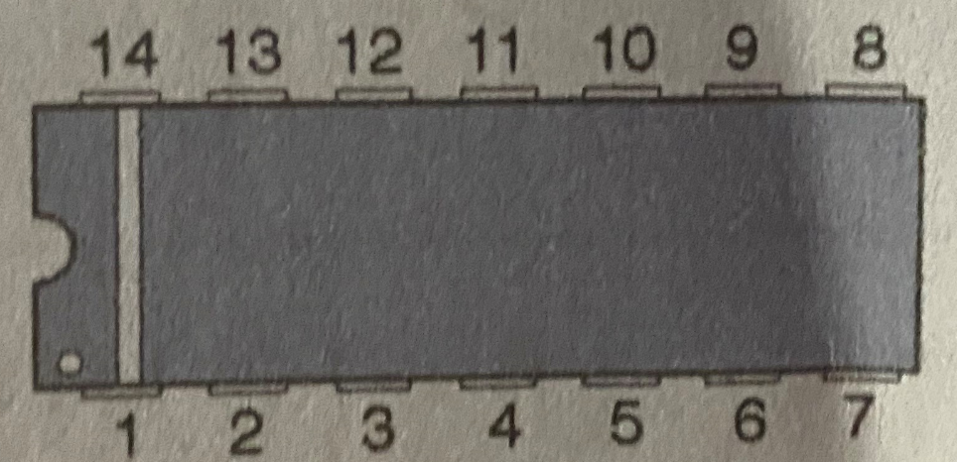

The structure of 4001 IC is shown below:

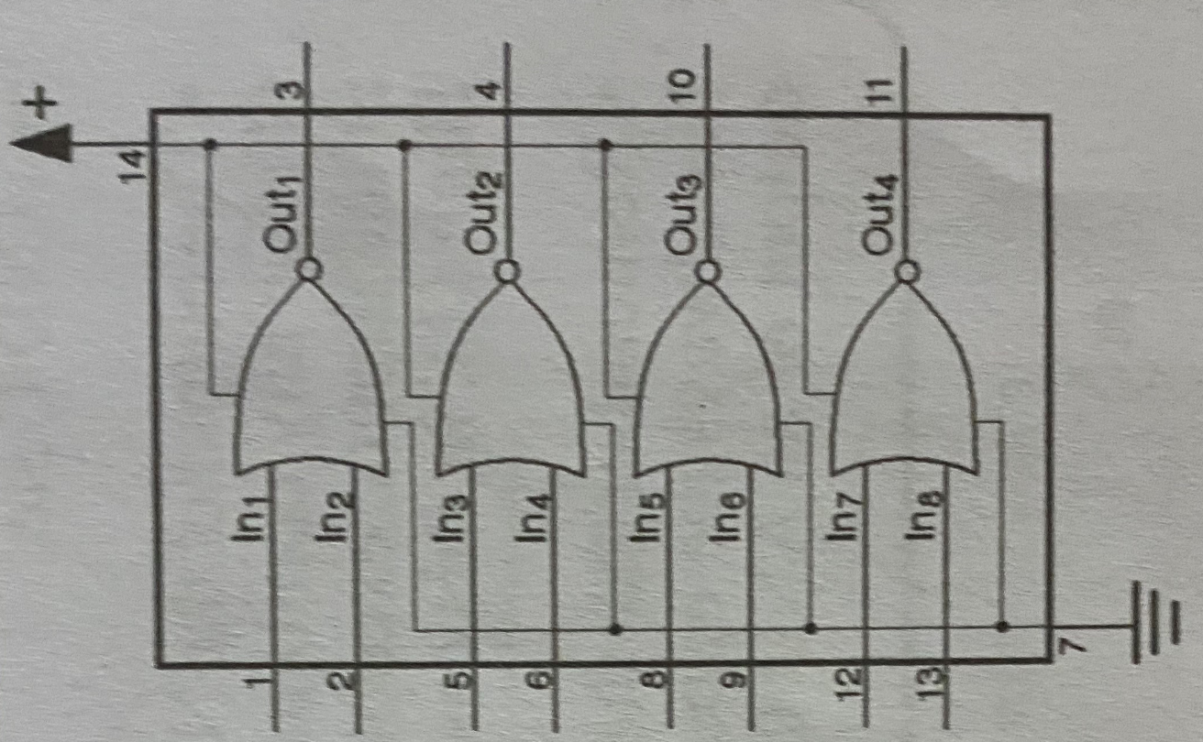

1. Verification and demonstration
2. Connect input S to positive bus strip and input R to negative bus strip, observe the LEDs.
3. Connect input S to negative, observe the LEDs.
4. Connect input S to negative bus strip and input R to positive bus strip, observe the LEDs.
5. Connect input R to negative, observe the LEDs

**If not checked in class, take the pictures of LEDs for four conditions and submit them in canvas.**